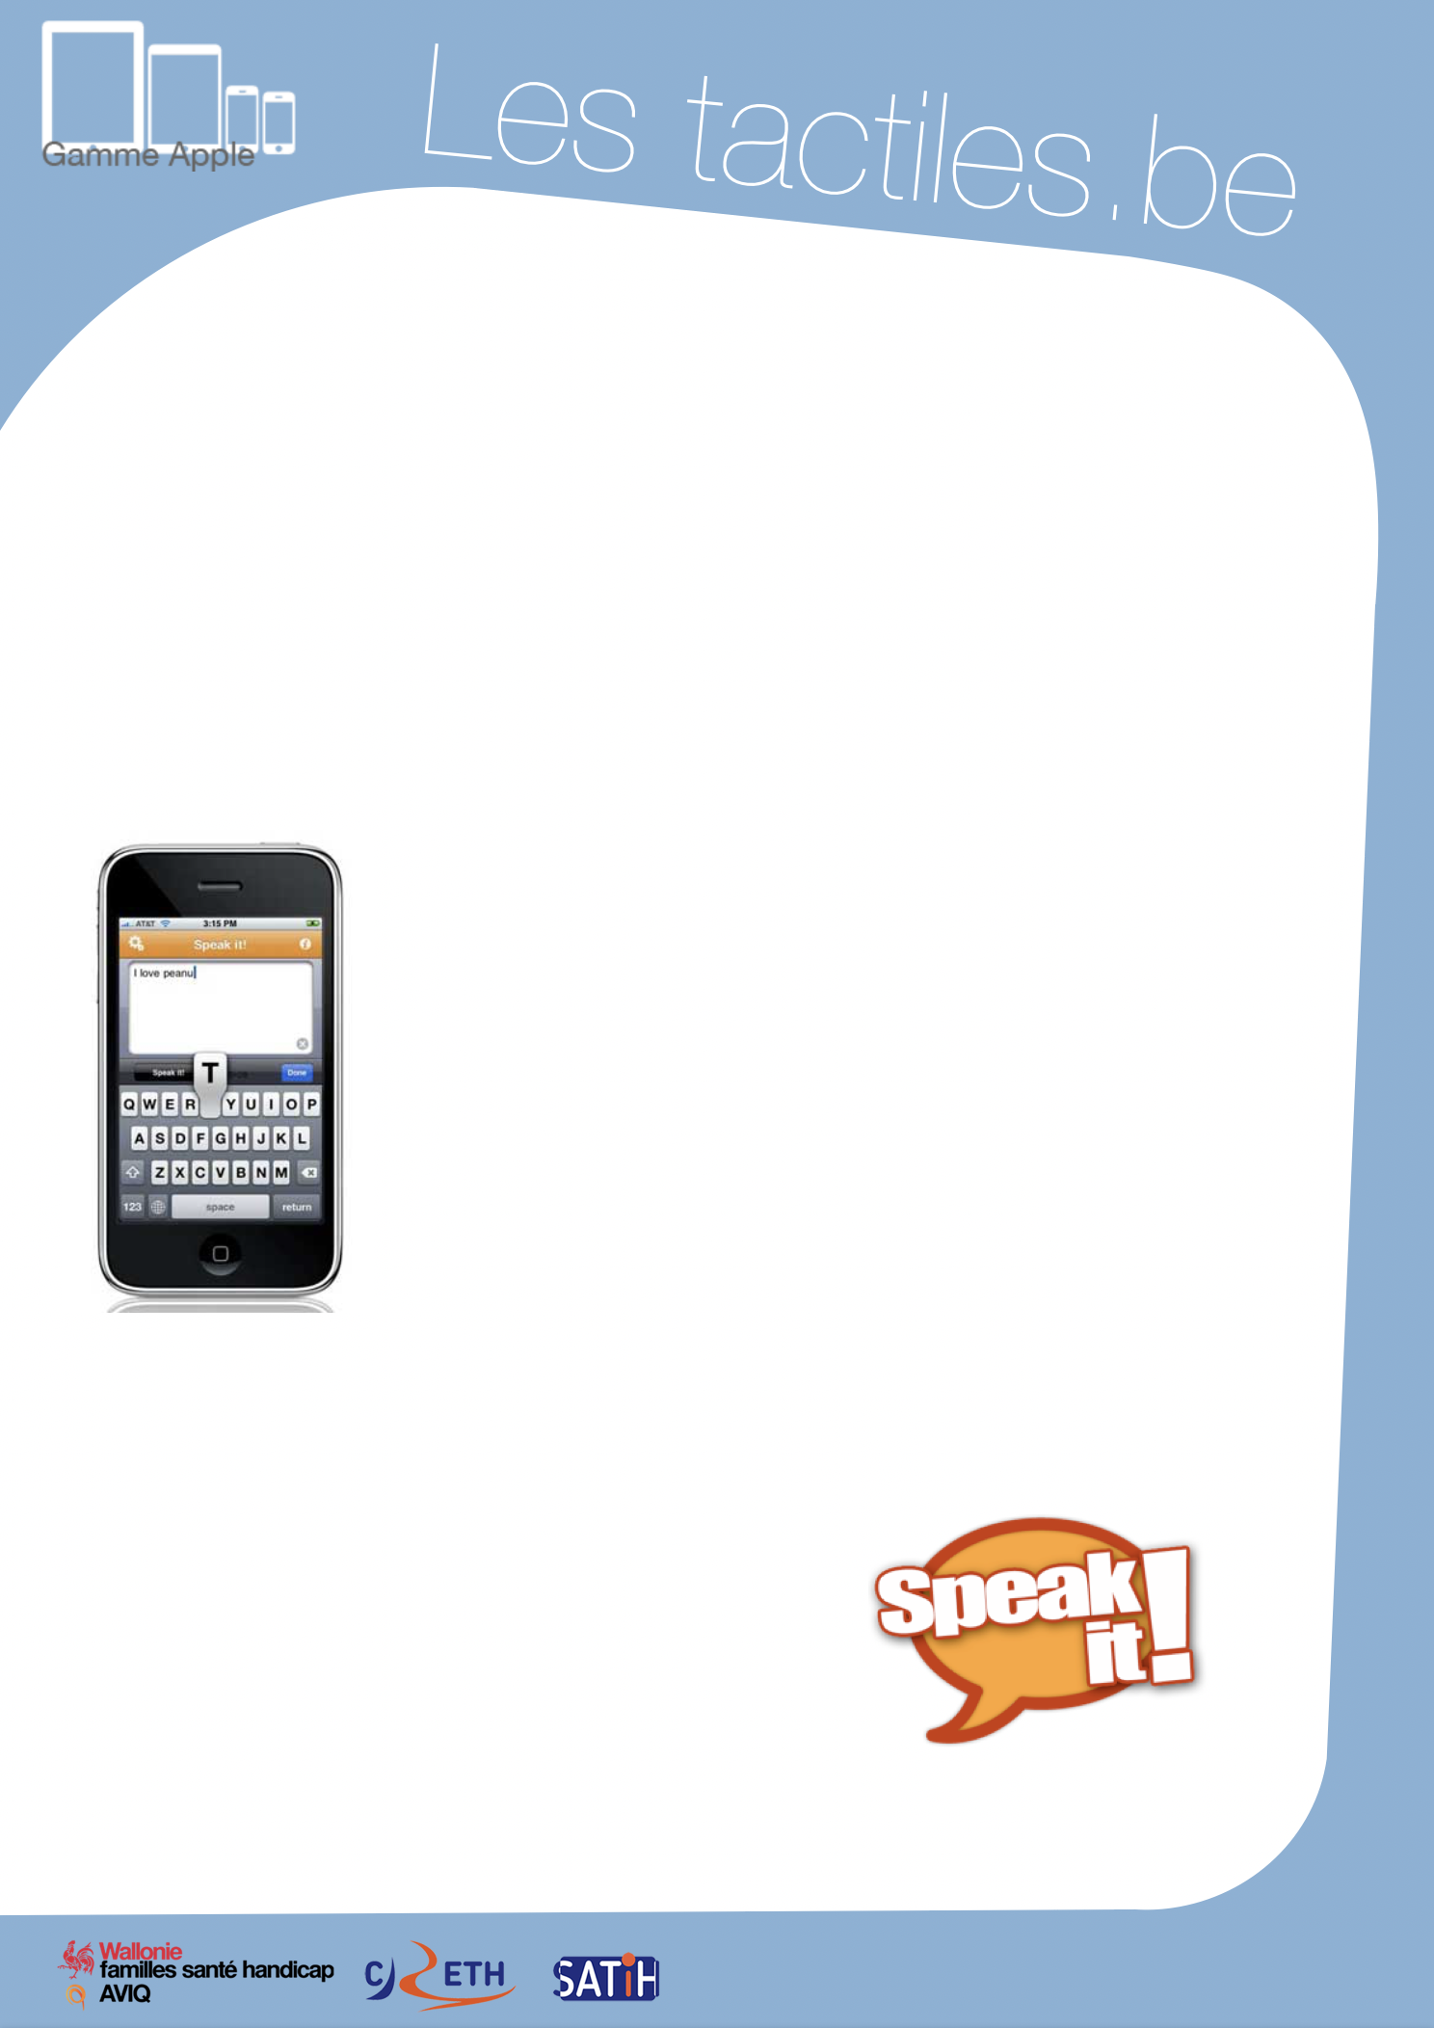

Link for Les tactiles.be

Image: A picture of Apple devices.

The accessibility tags of your tablets and smartphones

Communication by Alphanumerical

Keyboard with SPEAK IT

Foreword
Before reading this document, we recommend that you consult the general document on communication apps. This document highlights only what seems interesting and different from other applications.

Image: A picture of the Speak It! Application on iPhone.

What is Speak It
The application is simple, not very intuitive, and limited – but is sold for a good price (1.79 EUR).
Simple because it is refined.
Not intuitive because the button icons are not clear.
Limited because there is very little configuration possible compared to other communication applications with an alphabetic keyboard.
Good price compared to its competitors (which can go up to 109.99 EUR for some).

Speak It
€ 1.99 on the App Store

Our Advice
This application may not be the best in its category,
but its low price makes it worth discussing and
gives users an impression of what communication
applications by alphabetic keyboard are like.
For certain people, it is probably sufficient.

Image: A picture of the Speak It! logo.

Image: The logos of “Wallonie familles santé handicap AVIQ”, “CRETH” and “SATIH”.

